COMMUNITY SPONSORED PROJECT
Prototype-3
ARMANPREET KAUR 4535488 JASDEEP KAUR 4535999 KESHAV SHARMA 4532854 SALONI BEDI 4531676

Introduction
As mentioned in the earlier work, we have developed a mobile application/ mobile version for an existing website that is www.worldwirelesssolutions.com. To Commence with the previous version, the application was developed with the basic and static layout using containers and textboxes, and a single table used for data storage. However, the latest version not only has a modern look but also comes up with a greater number of screens to navigate which enhances the user’s experience by providing more information. Moreover, the latest version has got more space for data storage which reduces the risk of application crashing.

Progress
- Quick-Glance Screen
The latest version got a new look and a way to start the application by introducing the quick glance page. This page is designed specifically for the user who just wants to go through the application without entering the credentials. However, this category of users will only be able to access minimal information of the company as this screen is designed to navigate only three different screens using the buttons. The first button navigates to the Our Process Page, second to the Login Page and the last button for the Blogs and Articles Page. Other than that, this screen has textboxes for the textual information stored in the containers.
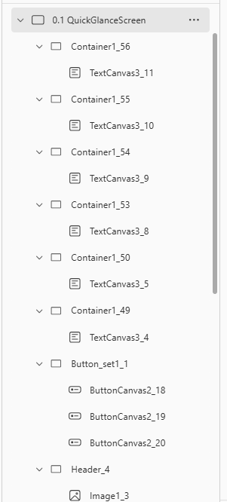

- Login-Screen
In the previous version, this screen used to be the startup screen for the application but in this version, it became the secondary screen. However, more information about the company can be found by entering the credentials on this screen. The Modern look has got the logo at the top, new Welcome Back! Tags for all users. The Sign-up button got shifted beside the newly added Label tag while the login button slightly reached the center of the screen.

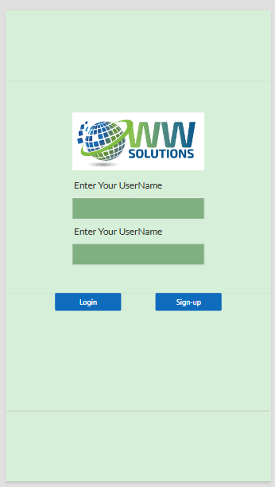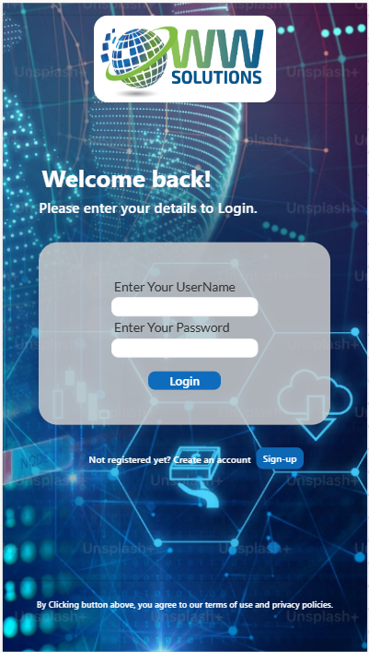

- Sign-up Screen
This screen was developed for new users who can enter their details and are able to utilize the full information provided. The user data was stored in the database in the form of the tables. Although there are no new add-ons but by adding a few colors and pictures and making the rounded corners around the central part of the screen this page got a fresh visual.
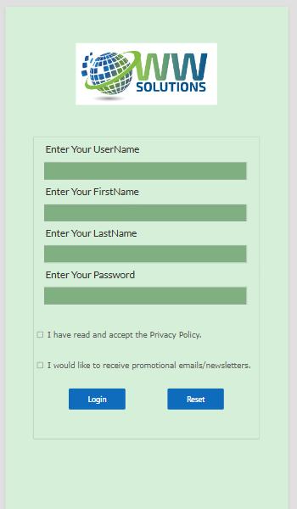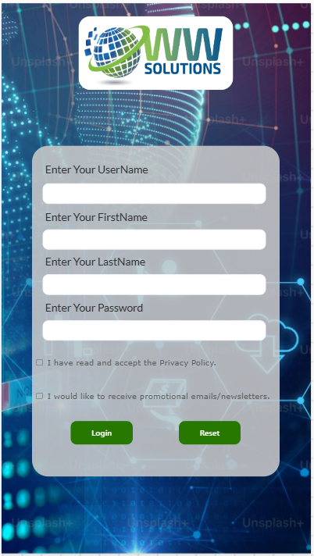

- Home-Page
The most pertinent screen of the application helps in navigating to six different screens. As compared to the previous version this one got the new green color to all six buttons and a rounded textboxes having white background make easier for the users to read.
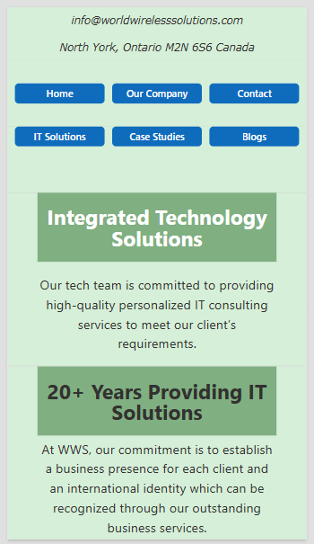

- Home-button Screen
As mentioned in prototype-2, this screen has a graph and just below which lies a button which used to be static but, in this version, it got a functionality of navigating to the newly developed screen named “Our Process”, other than that there is no new changes except the new look.
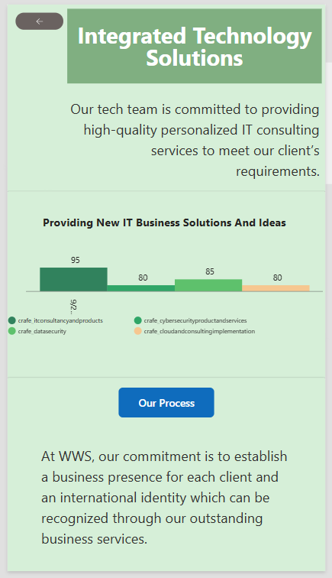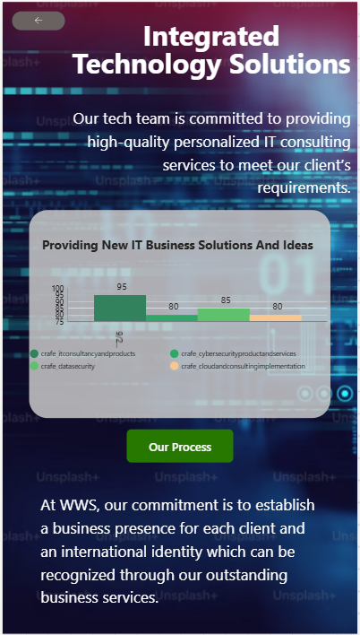

- Our Process
Commencing from the top left corner of the screen, a button is functioned for going back to the Home Page, beside which there is a container describing the topic headline and information. Moreover, three containers having a textbox and image are added to provide the information. Below are three more containers with just single textboxes in each.
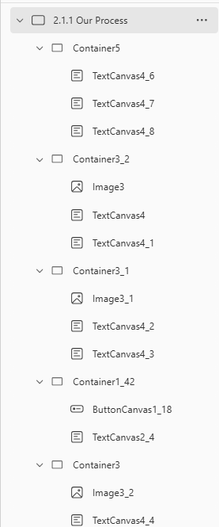

- Our Company Page
As like Home Button screen, this screen was also having a static button in the center of the screen which is now functioning to the “Meet Our Team” page. While keeping the rest of the screen layout same, a slight change has been made to the contact us button making it smaller and modern.


- Meet the Team
The page starts with the heading and the back navigation button stored in the single container. Below that, it has a heading for the “Executive Team” along with some information about the same. Coming to the middle of the screen, it is developed using four containers placed in a pair consisting of an image and a textbox. However, the screen ends up with the four functionable buttons navigating to the “Management Team”, “Operations Team”, “Cyber Security Team” and the “Contact Us” Page.
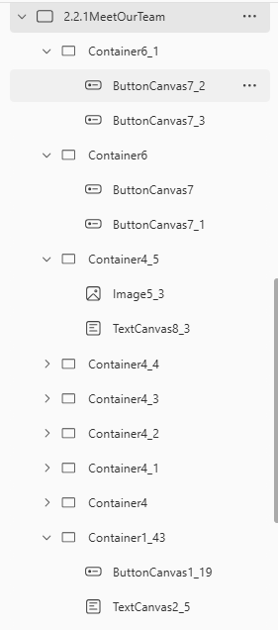

- Management Team and Operations Team
Coming to these screens, the common thing in both is the first container having the back button along with the heading. Starting with the Management Team page, it consists of eight containers having images and textboxes in each. On the other hand, Operations Team screen is developed using the textboxes within the containers and twenty-two containers are used to design the screen.
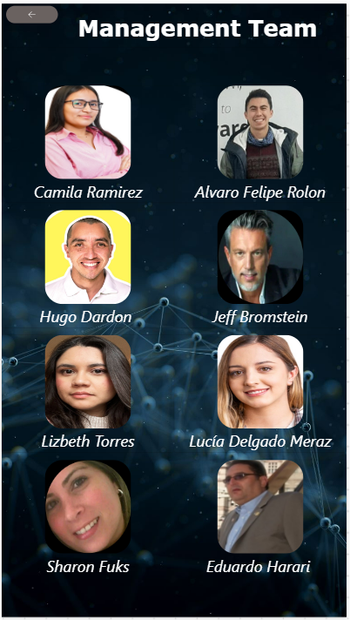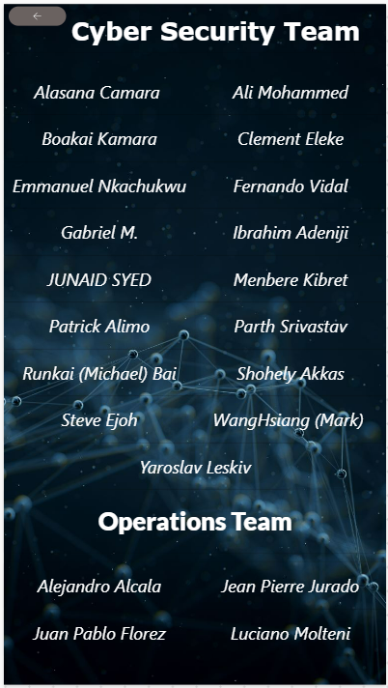
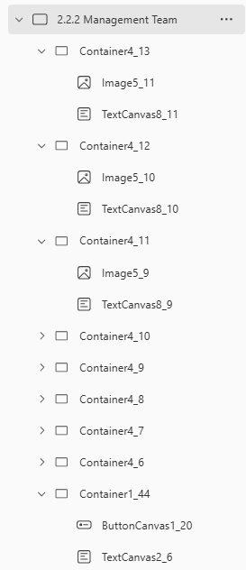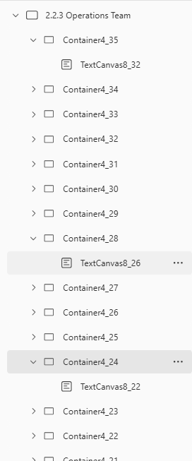

- Contact Us Page
As stated in prototype-2, this screen was developed using containers and the textboxes while having two static buttons in total. In the latest version, these are now functioned to provide the service of navigating to the “IT Solutions” Page whereas the button in the bottom of the screen helps in storing data in the database upon clicked. Other than that, this page got a new look with the updates to the textboxes by making the corners rounded and by changing the color of the buttons to the green.
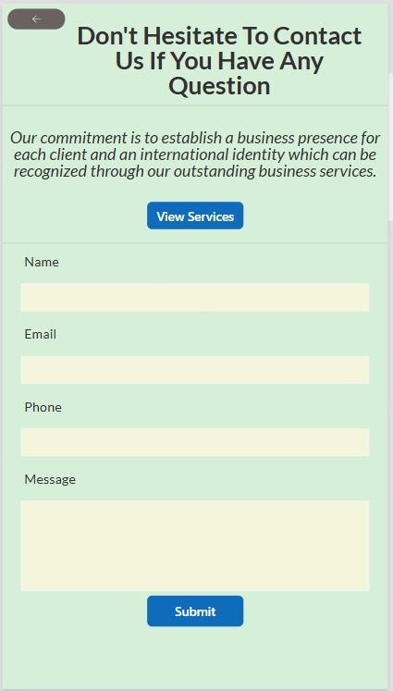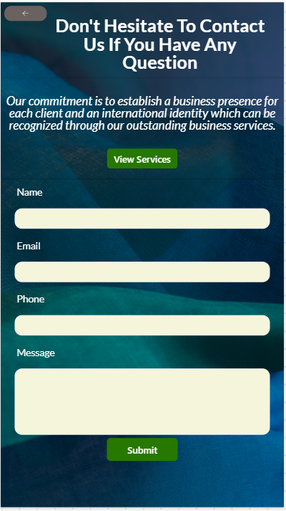

- IT Solutions Page
As mentioned before, this page had twelve static buttons with a basic layout. This screen was designed to provide information on what kind of services are available in the company by just showcasing the heading. But in the latest version of the application users can access the full information about specific service by clicking the “Read More” button respective to the heading. The clicked button will then navigate to the new screen as desired by the user.
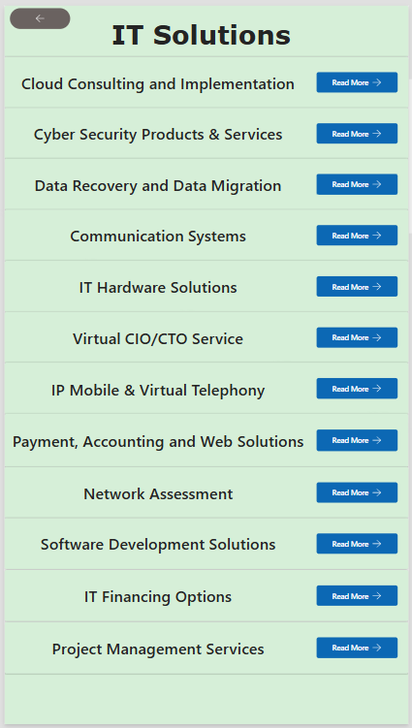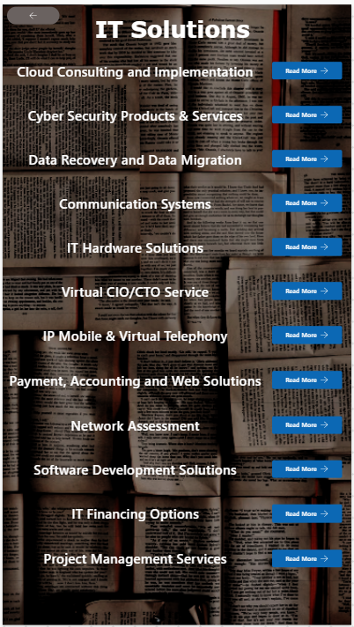

- Glance at the screens by clicking the Read More button
The below displayed pictures portray the screens which are accessible by clicking the Read More button on the IT solutions screen. These screens are designed using the same logic as the textboxes, containers and images. The images used as the logos are taken from the existing website and stored in the images folder of the mobile version. Moreover, these images are designed to provide access to the respective websites. For instance, If user clicks the image of the Amazon Cloud, the user will be redirected to the Amazon Cloud’s official website.
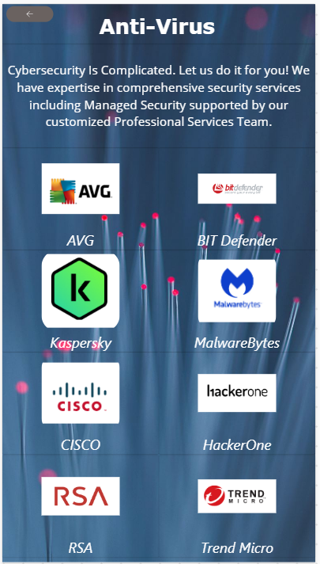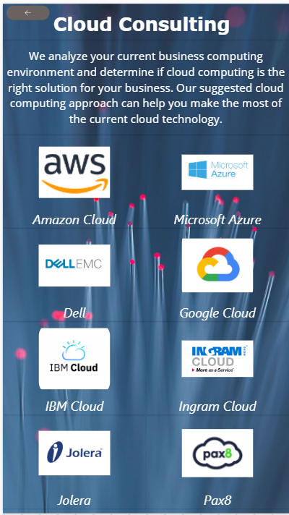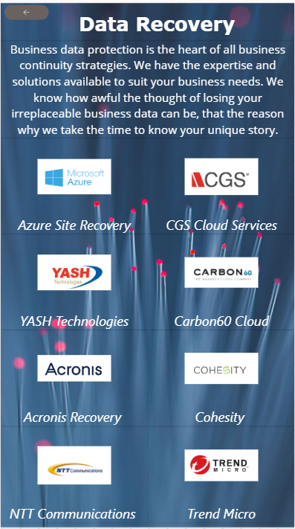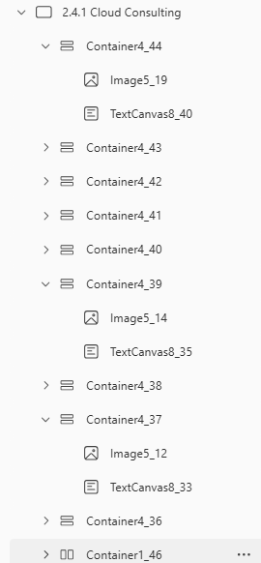

- Case Studies
The development of this screen was well explained in prototype-2. In the latest version, this screen got a modern look by adding the background image and by changing the body text color to white to make the text readable. However, the contact us button in the bottom right corner got a transition effect while navigating.
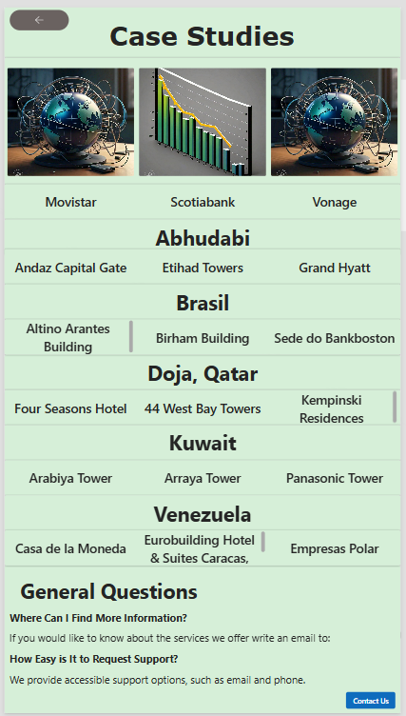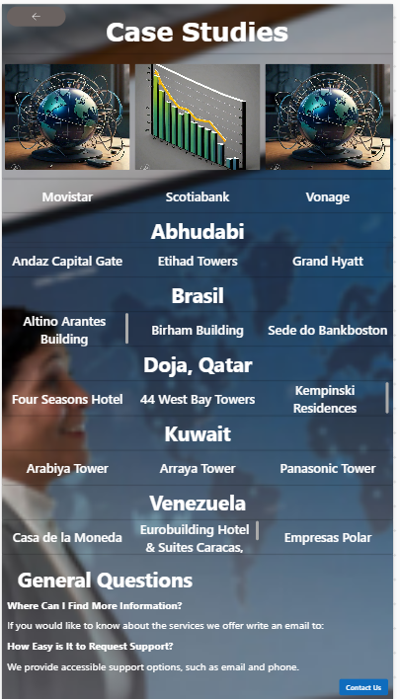

- Blogs and Articles
As like the above-described screen, this screen also does not have many noticeable changes, but a change has been provided to the images, which used to be static but are now able to redirect to a specific website as per mentioned on the image. For example, If the user clicks Domino’s image, the page will redirect it to the Domino’s official website.
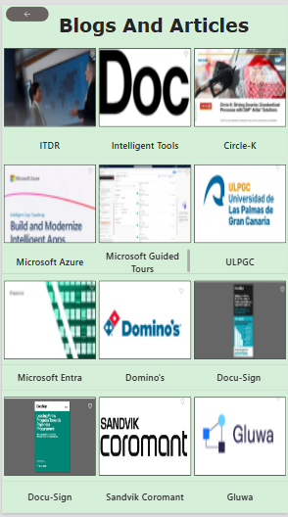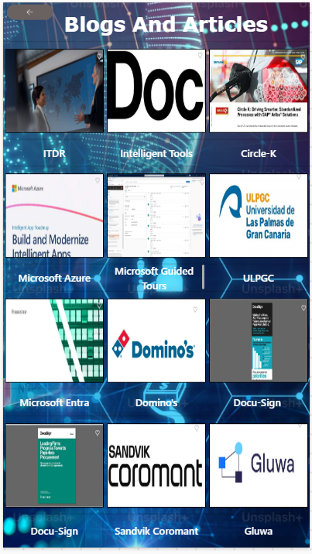

Working Model Demo

- Logics Behind the Sign-up Page
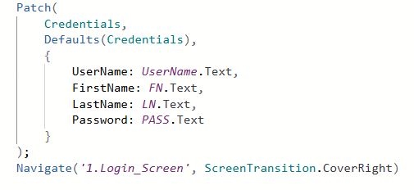
Using the Patch function, the user input can be stored in the database. Credentials is the name of the database, UserName, FirstName, LastName and Password written before the semicolon are the heading in the database whereas the UserName, FN, LN and PASS are the names of the textboxes inserted in the Sign-up page for the user input. The (text) is the datatype of the data entered in the form. Moreover, the navigation function in the last line is used to navigate to a new screen. In this case, it will navigate to the Login Screen after storing the user data into the database
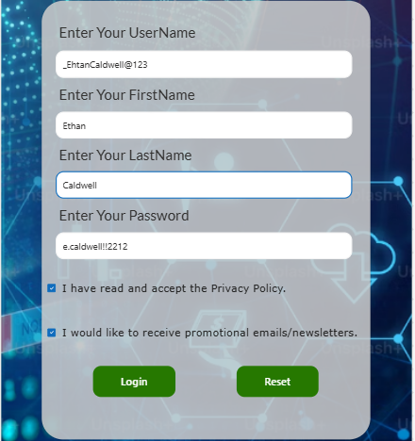
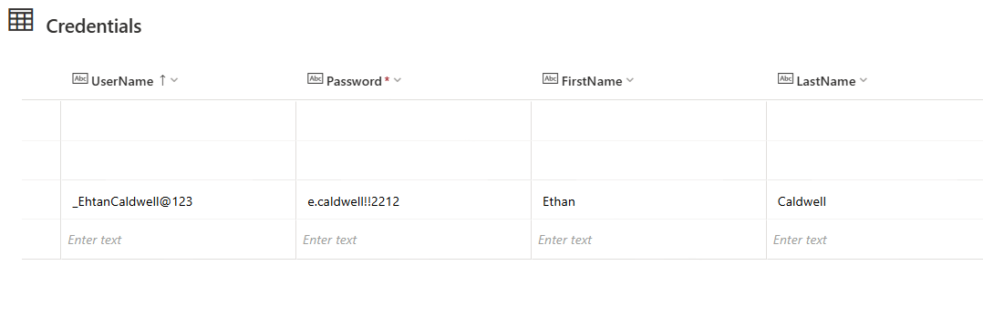
- Login Page
Starting with the IF function, it helps to evaluate the conditions and finds out a single value. However, IsBlank is used to make sure that the value or variable is empty or null. After that, Lookup Function helps with the data retrieval from the database and then navigate property helps in navigation. While entering the data if the user is invalid a notification will pop-up on the screen stating “Invalid User” using the Notify Command. These functions and commands need to be written in a single line using curly brackets.
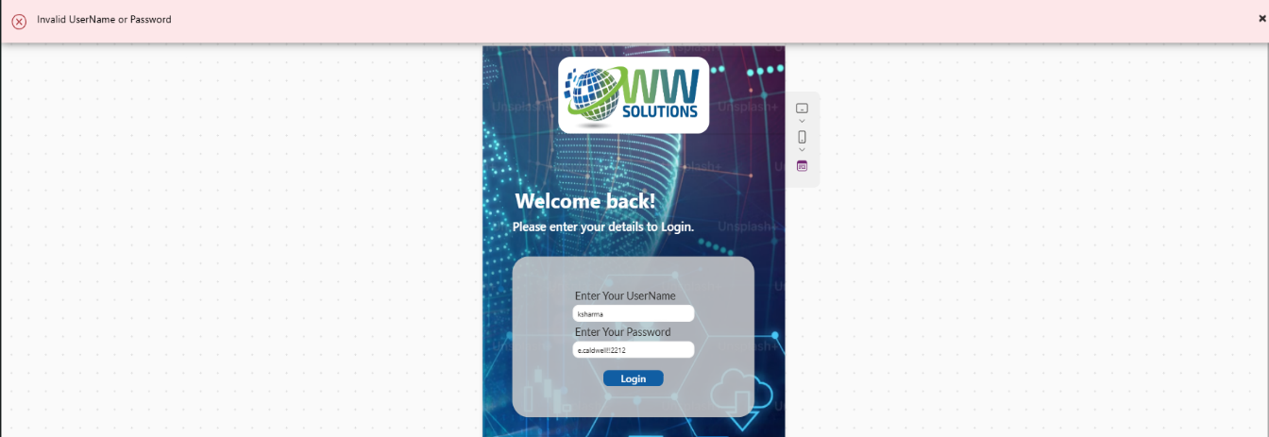
- Logics behind the Contact Us page
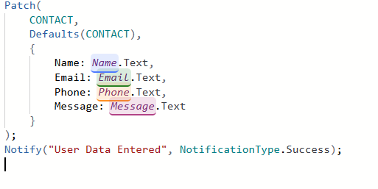
This is the same code which is used to store the user input in the database. The database name is CONTACT and the four textboxes are as follows: Name, Email, Phone and Message. Notify is used to provide the Success message after clicking the button to make sure the data is stored in the database.
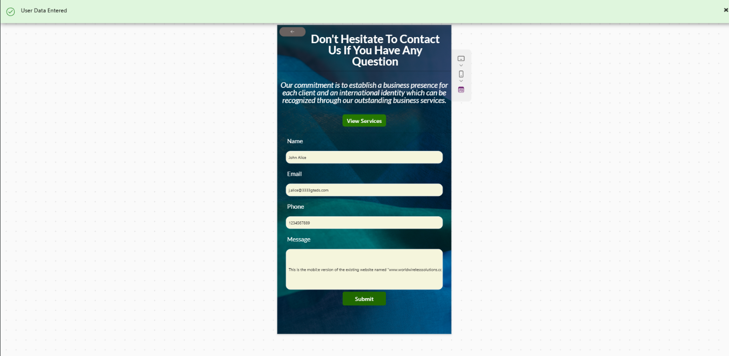
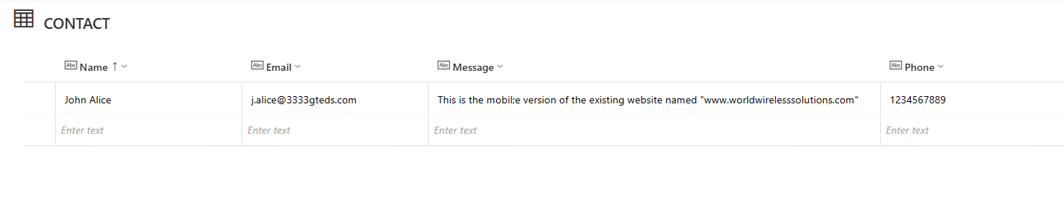
- Images Redirecting to the official websites
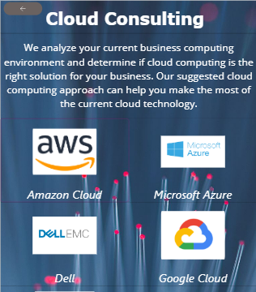
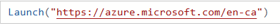
All the images that are provided in the mobile version were static just for the purpose of displaying but in the latest version it got the functionality of redirecting to the official websites respectively. This is possible because of the Launch Command in the power apps.
References
- How to add data to the tables
https://learn.microsoft.com/en-us/power-apps/maker/canvas-apps/create-edit-tables
- How to open websites from the images
https://www.youtube.com/watch?v=RBrB0Yf6LfA
- How to manage the text input controls
https://learn.microsoft.com/en-us/power-apps/maker/canvas-apps/controls/control-text-input
- How to use the Label properties
https://learn.microsoft.com/en-us/power-apps/maker/canvas-apps/controls/control-text-box
- How images are added in the mobile application
https://learn.microsoft.com/en-us/power-apps/maker/canvas-apps/controls/control-image

Conclusion
In this prototype, we have developed a greater number of screens to provide more information to the user. To commence with, Quick Glance screen has been added to the latest version, the sole purpose of that screen is to provide the user with minimal information without entering any credentials. Moreover, major upgrades were made to the designing part of the application. Finally, the database was also updated to reduce the chances of application crashing when user reach increases.

